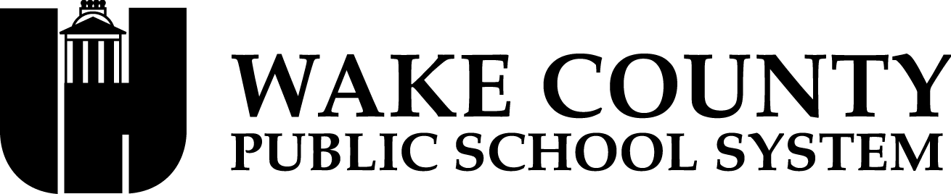



November 6, 2023

Dear Parent/Guardian,

Legislation (G.S. §115C-83.15) passed during the 2013 long session of the North Carolina General Assembly provides parents with an additional measure of school performance in the form of School Performance Grades. Beginning with the 2013–14 school year, the annual North Carolina School Report Cards display a letter grade of A, B, C, D, or F for each school in the state.

The School Performance Grades are based 80 percent on our school’s achievement score (student proficiency) and 20 percent on students’ academic growth. At Rolesville Middle school our achievement score for the 2022-2023 school year is based on how well our students performed on Grades 6-8 ELA and Math, Grade 8 Math and Math 1.

The purpose of this letter is to inform you that Rolesville Middle school, has been designated as a low performing school by the North Carolina State Board of Education. As defined in G.S. 115C-105.37: “The State Board of Education shall identify low-performing schools on an annual basis. Low-performing schools are those that earn an overall school performance grade of D or F and a school growth score of "met expected growth" or "not met expected growth" as defined by G.S. 115C-83.15.”

Rolesville Middle school received a School Performance Grade of D and a growth designation of Did Not Meetfor the 2022–2023 school year. Although we are committed to improving this score, it is important to remember that just as no one single score or grade tells the whole story of a student, neither does it tell you everything about the performance of a school or the opportunities that our school provides.

As a low performing school, we are required to develop an improvement plan that specifically addresses how the school will improve both the school performance grade and school growth score. The plan also includes how the superintendent and other central office administrators in the district will work with us and monitor the progress of our school. Our plan will be presented to our school board for approval at the November 7, 2023, meeting. The final plan will be available for review <https://www.wcpss.net/rolesvillems>.

One of our top priorities for 2023–2024 is to improve our School Performance Grade. There are a number of key programs we have in place to help improve student performance. These include:

* Core instructional time has increased to 70 minutes each day; to allow teachers sufficient time to address students’ instructional needs.
* Teachers are administering classroom based and district assessments regularly and monitoring student performance.
* Teachers are receiving professional development on supporting the academic needs of targeted subgroups that did not make growth during the 22-23 school year.

We hope you will closely follow your student’s academic progress and work with his or her teacher(s) to help ensure they stay on track academically. Working together as a team, we can improve not only how well our students are performing individually, but how our school is performing as a whole. There is nothing more important to administrators and teachers at Rolesville Middle School than ensuring students are ready for the next step in their academic careers. I look forward to working with you to make sure your student is on track for success.

If you have any questions or concerns regarding our School Performance Grade and how we plan to improve, please don’t hesitate to contact me at [acooper2@wcpss.net](mailto:acooper2@wcpss.net) or at 919-570-2260.

Sincerely,

Angela R. Cooper

Principal